- What can a SQL statement accomplish?

- Sort records
- Choose fields
- Choose records
- Cross reference tables
- Perform calculations
- Provide data for database reports
- Modify data

- All SQL keywords in a SQL statement will be typed in upper case letters. Even though SQL is ‘case-insensitive,’ this is good programming practice and allows us (and others) to differentiate between keywords and other information in a SQL statement.

- String information imbedded within a SQL statement can be enclosed in double-quotes (“) or single-quotes (‘). With Visual Basic, you should only use single-quotes to enclose imbedded strings. The reason for this is that the SQL statement is itself a string - so, in Visual Basic code, SQL statements must be enclosed in double-quotes. We enclose imbedded strings with single-quotes to avoid confusion.

- SQL supports the use of wildcards in forming data views. The wildcard character for the Jet engine is an asterisk (*). Use of wildcards will be illustrated in many examples. ANSI Standard SQL implementations use the percent sign (%) as a wildcard.

- If a table or field name has an imbedded space, that name must be enclosed in brackets ([]). For example, if the table name is My Big Table, in a SQL statement you would use:

[My Big Table]

This notation is not allowed in some SQL implementations. But in implementations that don’t recognize brackets, imbedded spaces in table and field names are not allowed, so it should never be a problem.

- To refer to a particular field in a particular table in a SQL statement, use a dot notation:

TableName.FieldName

If either the table or field name has imbedded spaces, it must be enclosed in brackets.

Where Does SQL Fit In Visual Basic?

- Visual Basic uses SQL queries to define a data source. SQL statements are processed by the Jet database engine (whether using DAO or ADO technology) to form a recordset object. This object contains the virtual database table formed as a result of the SQL statement. The resulting object can be used to display and, perhaps, update the database.
SQL with the DAO Data Control

- When using the DAO (data access object) data control, the SQL statement takes the place of the RecordSource property of the control. In design mode, simply go to the Properties Window for the data control, scroll down to the RecordSource property and type in a valid SQL statement. Many times, this will be a very long property. Obviously, it is assumed that the DatabaseName property of the data control has been set to the desired database file.

- In run mode, the SQL statement is also assigned to the RecordSource property of the data control (Refresh the data control after assigning the RecordSource). For example, if we have a SQL statement named MySQL (this will be a string type variable) we want to use with a data control named datDAOExample (again, it is assumed that the DatabaseName property has been appropriately set), the BASIC code syntax is:

datDAOExample.RecordSource = MySQL
datDAOExample.Refresh

We usually set the RecordSource property (and DatabaseName property, also) at run-time, rather than in design mode. Reasons for this are discussed in later chapters.

- Whether in design or run mode, a valid SQL statement will return a Recordset object containing the selected database records. This object will have its own methods and properties for our use. In particular, to establish a valid RecordCount for the Recordset returned using a data control named datDAOExample, use these two lines of code:

datDAOExample.Recordset.MoveLast
datDAOExample.Recordset.MoveFirst

Following these lines, the RecordCount is examined using:

datDAOExample.Recordset.RecordCount

Quick Example 1 - SQL with the DAO Data Control

- Start a new project. Add two label controls and a DAO data control. Set two data control properties to:

DatabaseName BIBLIO.MDB (point to your working copy)
RecordSource SELECT * FROM Titles

After setting the RecordSource property, the Properties Window should look like this:

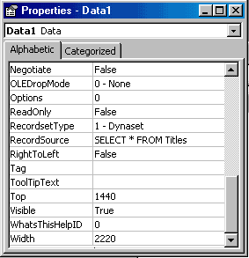

Yes, this is your first SQL statement! You don’t have to recognize this right now, but it’s pretty easy to understand. The statement says SELECT all fields (the wildcard *) FROM the Titles table. This has the same result as choosing the Titles table as the RecordSource property.

- Set the following two properties for the first label control (Label1):

DataSource Data1
DataField Title

- Place this code in the Form_Activate procedure (this counts and displays the number of records):

Private Sub Form_Activate()
Data1.Recordset.MoveLast
Data1.Recordset.MoveFirst
Label2.Caption = Data1.Recordset.RecordCount
End Sub

- Save and run the application. You should see this (the first label control showing a title and the second a number (the number of returned records):

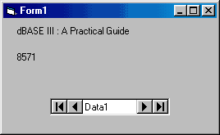

Scroll through different titles using the data control arrows.

- Now, add these two lines at the top of the Form_Activate procedure (these lines set the RecordSource at run-time):

Data1.RecordSource = "SELECT * FROM Titles ORDER BY Title"
Data1.Refresh

The SQL statement (enclosed in quotes since it is a BASIC string variable) is modified so the results are in alphabetical order.

- Save and rerun the application. The ‘in code’ SQL statement should produce the same records, but in order:

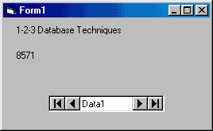

SQL with the ADO Data Control

- When using the ADO (ActiveX data object) data control, the SQL statement takes the place of the RecordSource property of the control. In design mode:

- Establish the ConnectionString property.
- Go to the Properties Window for the data control, scroll down to the RecordSource property and click on the ellipsis that appears. The RecordSource Property Page will appear.
- Under Command Type, select 1 - adCmdText (this tells the control we will be using a SQL statement). Then, in the Command Text (SQL) window, type in a valid SQL statement. When done, click OK.

- In run mode, the SQL statement is also assigned to the RecordSource property of the data control (Refresh the data control after assigning the RecordSource). For example, if we have a SQL statement named MySQL (this will be a string type variable) we want to use with a data control named datADOExample (again, it is assumed that the ConnectionString property has been appropriately set), the BASIC code syntax is:

datADOExample.RecordSource = MySQL
datADOExample.Refresh

We usually set the RecordSource property (and ConnectionString property, also) at run-time, rather than in design mode. Reasons for this are discussed in later chapters.

- Whether in design or run mode, a valid SQL statement will return a Recordset object containing the selected database records. This object will have its own methods and properties for our use. In particular, to establish a valid RecordCount for the Recordset returned using a data control named datADOExample, use these two lines of code:

datADOExample.Recordset.MoveLast
datADOExample.Recordset.MoveFirst

Following these lines, the RecordCount is examined using:

datADOExample.Recordset.RecordCount

Quick Example 2 - SQL with the ADO Data Control

- Start a new project. Add two label controls and an ADO data control. Build the data control ConnectionString property to point to your working copy of BIBLIO.MDB.

- Go to the Properties Window and click on the data control’s RecordSource property. Click the ellipsis. The RecordSource Property Page will appear. Under Command Type, select 1 - adCmdText. Then, in the Command Text (SQL) window, type:

SELECT * FROM Titles

You should see:

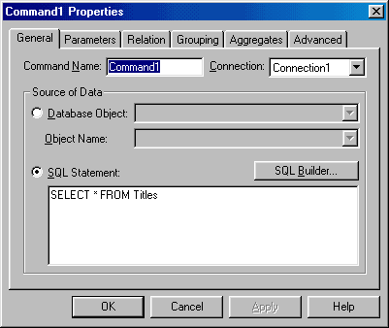

When done, click OK.

- Set the following two properties for the first label control (Label1):

DataSource Adodc1
DataField Title

- Place this code in the Form_Activate procedure (this counts and displays the number of records):

Private Sub Form_Activate()
Adodc1.Recordset.MoveLast
Adodc1.Recordset.MoveFirst
Label2.Caption = Adodc1.Recordset.RecordCount
End Sub

- Save and run the application. You should see something like this (the first label control showing a title and the second a number (the number of returned records):

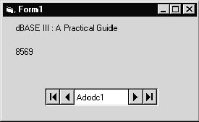

Scroll through different titles using the data control arrows.

- Add these two lines at the top of the Form_Activate procedure (these lines set the RecordSource at run-time) to modify the SQL statement:

Data1.RecordSource = "SELECT * FROM Titles ORDER BY Title"
Data1.Refresh

- Save and rerun the application. The ‘in code’ SQL statement should produce the same records, but in order:

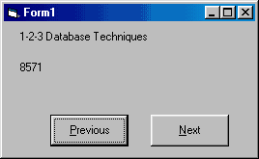

SQL with the ADO Data Environment

- When using the ADO (ActiveX data object) data environment, the SQL statement forms a new Command object within an existing Connection object. In design mode:

- Establish the Connection object (connect to a database).
- Right-click on the Connection object in the Data Environment window and select Add Command. A new Command object will appear.
- Right click the Command object and select Properties. The Properties window appears - make sure the General tab is selected. Under Source of Data, click SQL Statement. The SQL window will become enabled. Type a valid SQL statement, then click OK.

(In all these steps, it is assumed that proper conventions were followed in naming all objects.)

- With the ADO data environment, we follow a different approach when using SQL statements in run mode. The recordset created based on design-time parameters is first closed (use the Close method). Then, we re-open the recordset using the Open method and the new SQL statement. For example, assume we have a data environment named denExample, a command object named comExample and a new SQL statement named MySQL (this will be a string type variable). Recall the recordset associated with comExample will be named rscomExample. The code to close the current recordset and re-open it with a new SQL statement is:

denExample.rscomExample.Close
denExample.rscomExample.Open MySQL

We’re not done, though. One more step is needed.

- After creating the new recordset, all data bound controls are left bound to the original recordset. Without manually rebinding (in code) the controls to the new recordset, you won’t see the new results. Microsoft, in their Knowledge Base Articles, claims this is an intended behavior. We believe it is a bug that will hopefully be addressed as ADO technology matures. To rebind the data bound controls to the ADO data environment, you need to reset each control’s DataSource property. The code to rebind a control named ExampleControl to a data environment named DataEnvironmentName is:

Set ExampleControl.DataSource = DataEnvironmentName

Note use of the Set statement. Set must be used when initializing a programming object, as we are here. We will look at some automated techniques for rebinding in a later chapter. You can see that working with the data environment is a little trickier. But, after you’ve used it a few times, you’ll begin to appreciate its great advantages.

- Whether in design or run mode, a valid SQL statement will return a recordset object containing the selected database records. Recall, in our example above, the returned recordset is named rscomExample. This object will have its own methods and properties for our use. In particular, to establish a valid RecordCount for the recordset returned by a data environment named denExample, use these two lines of code:

denExample.rscomExample.MoveLast
denExample.rscomExample.MoveFirst

Following these lines, the RecordCount is examined using:

denExample.rscomExample.RecordCount

Quick Example 3 - SQL with the ADO Data Environment

- Start a new project. Add two label controls and two command buttons (needed to allow navigation among records). Add a Data Environment in the Project Explorer window. Right-click Connection1 and set Properties so it points to your working copy of BIBLIO.MDB.

- Right-click on Connection1 and select Add Command. A new Command object will appear. Right click that object and select Properties. The Properties window appears - make sure the General tab is selected. Under Source of Data, click SQL Statement. The SQL window will become enabled. Type:

SELECT * FROM Titles

You should see:
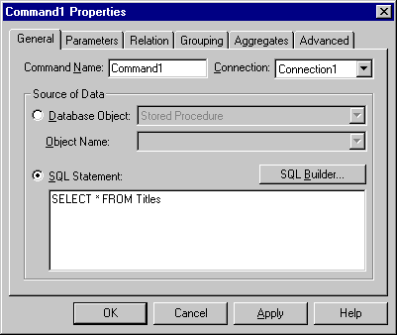

When done, click OK.

- Set the following properties for the first label control and the two command buttons:

Label1:
DataSource DataEnvironment1
DataMember Command1
DataField Title

Command1:
Caption &Previous

Command2:
Caption &Next

- Place this code in the Form_Activate procedure (this counts and displays the number of records):

Private Sub Form_Activate()
DataEnvironment1.rsCommand1.MoveLast
DataEnvironment1.rsCommand1.MoveFirst
Label2.Caption = DataEnvironment1.rsCommand1.RecordCount
End Sub

- Add this code to the command button Click events to allow navigation:

Private Sub Command1_Click()
DataEnvironment1.rsCommand1.MovePrevious
If DataEnvironment1.rsCommand1.BOF Then
DataEnvironment1.rsCommand1.MoveFirst
End If
End Sub

Private Sub Command2_Click()

DataEnvironment1.rsCommand1.MoveNext
If DataEnvironment1.rsCommand1.EOF Then
DataEnvironment1.rsCommand1.MoveLast
End If
End Sub

- Save and run the application. You should see something like this (the first label control showing a title and the second a number (the number of returned records – this may be a different value for you, depending on the current state of the BIBLIO.MDB database):

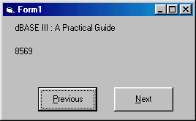

Navigate through the records, if you like.

- Add these three lines at the top of the Form_Activate procedure (these lines set the RecordSource at run-time):

DataEnvironment1.rsCommand1.Close
DataEnvironment1.rsCommand1.Open "SELECT * FROM Titles ORDER BY Title"

Set Label1.DataSource = DataEnvironment1

These lines close the old recordset, re-open it with the new SQL statement, and then rebind the label control to the data environment.

- Save and rerun the application. You obtain the same records, but ordered:

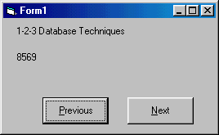

SQL Tester

Well, now we know some of the rules and syntax of SQL statements and how to use them with Visual Basic, but we still don’t know what a SQL statement looks like (well, we saw one in the examples). We correct all that now and start learning more about SQL. To test SQL statements we form, we build this example which allows us to enter SQL statements and see the results of the formed database queries. In this example, we use the DAO data control so both Visual Basic 5 and Visual Basic 6 users can build the same example. You can choose to use the ADO control (or data environment) if you choose.

- Start a new project. Add a DAO data control, a text box control, two label controls, a command button, and a DBGrid control to the form. Wait, you say, what is a DBGrid Control and why isn’t it in the toolbox? It is a DAO data bound control we haven’t looked at yet, but it is very powerful. The DBGrid control allows us to view and edit an entire database table by setting just one property (DataSource). It is a custom control that must be added to the toolbox. To do this, select Components under the Project menu item. In the window that appears, check the box next to Microsoft Data Bound Grid Control, then click OK. It is then available for selection from the toolbox. We will look further at this control in Chapter 6. Resize and position the controls so your form looks something like this:

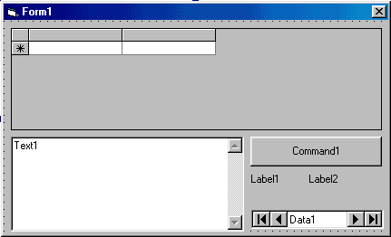

A Brief (Hopefully) Interlude for Visual Basic 6 Users:

When you selected the Components tab, the choice for the Microsoft Data Bound Grid Control may not have been there. You will see a choice for Microsoft DataGrid Control. This is not the same control – this is the version of the control that works with ADO technology. So what can you do? There are two solutions: a quick one and a ‘not-so-quick’ one. We recommend the latter.

Solution 1 – The Quick Solution:

Use the ADO DataGrid control (make sure it has been added to the toolbox) in place of the DAO data bound grid control. You will also have to replace the DAO data control with the ADO data control. Use the same properties for the grid control and the data control with one exception. Recall the ADO data control does not have a DatabaseName property. If using the ADO control, set the ConnectionString property such that it points to your working copy of the BIBLIO.MDB database. No code changes are necessary – the code that works for the DAO data control will work for the ADO data control.

When you attempt setting the DataSource property for the grid control, you will get this error message:

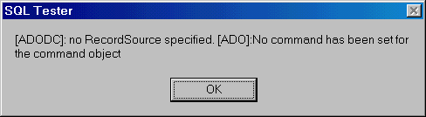

This is acceptable since we will be setting the data control’s RecordSource at run-time. You may also get this error when running the application. If so, just click OK. For your reference, we have built an ADO version of the SQL Tester program and included it with the example files (look for the project file with the AD suffix).

Solution 2 – The ‘Not-So-Quick’ Solution:

Here, we will install the desired DAO data grid control (and other DAO-based controls, if desired) onto your computer. The steps are many, but the effort is worth it, especially if you ever plan to use or build applications that employ DAO database technology. The information provided here was taken from Microsoft’s website. You will need your installation CD for Visual Basic 6. You will also have to be familiar with issuing DOS command line statements. Ask for help from someone if this is unfamiliar.

Look in the \COMMON\TOOLS\VB\CONTROLS directory on the VB6 CD. This directory contains controls that shipped with Visual Basic 4/5 Professional and Enterprise Editions, which are no longer shipping with Visual Basic 6:

AniBtn32.ocx, Gauge32.ocx, Grid32.ocx (the file we are interested in here), KeySta32.ocx, MSOutl32.ocx, Spin32.ocx, Threed32.ocx, MSChart.ocx

To install these files on your computer, follow these steps:

- Copy all of the files in this directory to your \WINDOWS\SYSTEM directory.

- Register the controls by either Browsing to them in Visual Basic itself (select the Browse option when selecting Components), or manually register them using RegSvr32.Exe. RegSvr32.EXE can be found in the \COMMON\TOOLS\VB\REGUTILS directory. The DOS command line is:

regsvr32.exe grid32.ocx

- Register the design time licenses for the controls. To do this, merge the vbctrls.reg file found in the \COMMON\TOOLS\VB\CONTROLS directory into your registry. You can merge this file into your registry using RegEdit.Exe (Win95, Win98, WinMe, Win2000 or WinNT4) or RegEd32.Exe (WinNT3.51):

regedit vbctrls.reg (or other reg files associated with the controls)

The DAO files (including the DAO data grid control) should now appear in the Components listing when choosing controls to add to your toolbox. Now back to our example.

Set properties for the form and controls:

Form1:
Name frmSQLTester
BorderStyle 1-Fixed Single
Caption SQL Tester

Data1:
Name datSQLTester
Caption SQL Tester
DatabaseName BIBLIO.MDB (point to your working copy)

Label1:
Caption Records Returned

Label2:
Name lblRecords
Alignment 2-Center
BackColor White
BorderStyle 1-Fixed Single
Caption 0
FontSize 12

Command1:
Name cmdTest
Caption Test SQL Statement
TabStop False

DBGrid1:
Name grdSQLTester
DataSource datSQLTester
TabStop False

Text1:
Name txtSQLTester
MultiLine True
ScrollBars 2-Vertical

When done, the form should look like this:

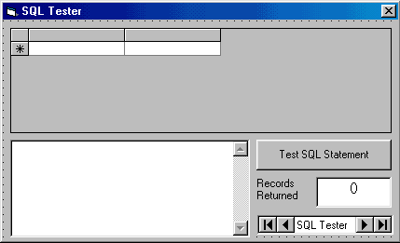

With this example, we will type SQL statements in the text box area, then click the Test SQL Statement button. The data grid will display the returned records, while the label control will display the number of records returned. We need some code to do all of this.

- All the code goes in the cmdTest_Click event:

Private Sub cmdTest_Click()
'Enable error handling
On Error GoTo SQLError
'Read SQL statement and establish Recordsource
datSQLTester.RecordSource = txtSQLTester.Text
datSQLTester.Refresh
If datSQLTester.Recordset.RecordCount <> 0 Then
datSQLTester.Recordset.MoveLast
datSQLTester.Recordset.MoveFirst
lblRecords.Caption = datSQLTester.Recordset.RecordCount
Else
lblRecords.Caption = "0"
End If
txtSQLTester.SetFocus
Exit Sub
'If error occurs, report it in message box
SQLError:
MsgBox Error(Err.Number), vbExclamation + vbOKOnly, "SQL Error"
Exit Sub
End Sub
Let’s spend some time seeing what’s going on in this code. The first thing we do is turn on error trapping. Without it, if we make a small error in a SQL statement, the program will stop. With it, we get a message indicating our mistake and are allowed to continue. Following error control, the SQL statement (from txtSQLTester) is processed and the Recordset established. The records are then counted and displayed.

Be careful in typing SQL statements. Although we have error trapping in SQL Tester, if you make a mistake, the returned error messages are (many times) not of much help. If you get an error, the best thing to do is retype the SQL command, paying attention to spacing, spelling, and proper punctuation.

- Save the application and run it. Type the only SQL statement you know at this time in the text box (SELECT * FROM Titles). Click Test SQL Statement and you should see:

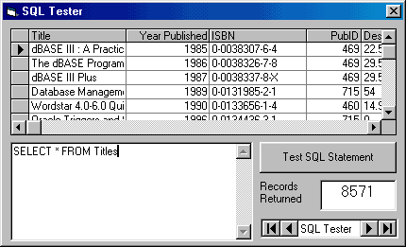

Note the DB grid control display the entire table. You can scroll through the table or edit any values you choose. Any changes are automatically reflected in the underlying database. Column widths can be changed at run-time. Multiple row and column selections are possible. As we said, it’s a very powerful tool. Please note Records Returned values for your results may be different, depending on the current data in the database.

Change the word SELECT to SLECT to make sure the error trapping works. Now, let’s use this SQL Tester to examine many kinds of SQL statements. When typing the statements, use upper case letters for the SQL keywords. Statements do not necessarily have be on a single line - multiple line SQL statements are fine and usually make them easier to read and understand.

SELECT/FROM SQL Statement

- The most commonly used SQL statement is the one we’ve been using as an example: the SELECT/FROM statement. This statement allows you to pick fields from one or more tables.

- The syntax for a SELECT/FROM SQL statement is:

SELECT [Fields] FROM [Tables]

where [Fields] is a list of the fields desired and [Tables] is a list of the tables where the fields are to be found. The wildcard character (*) can be used for the fields list to select all fields from the listed table(s). For example, the statement we have been using:

SELECT * FROM Titles

selects and returns all fields from the BIBLIO.MDB database Titles table. Look at all fields in the other tables (Authors, Publishers, Title Author) using similar statements. When looking at the Title Author table, you need to write:

SELECT * FROM [Title Author]

Recall field and table names with imbedded spaces must be enclosed in brackets. Looking at each table will reacquaint you with the structure of the BIBLIO.MDB database tables and fields. We will use a lot in the rest of this chapter.

- If we only want selected fields from a table, we use a field list, which is a comma-delimited list of the fields desired, or:

SELECT Field1, Field2, Field3 FROM Table

will return three named fields from Table. Make sure you do not put a comma after the last field name. To obtain just the Title and Year Published (name must be enclosed in brackets because of imbedded space) fields from the books database Titles table, use:

SELECT Title,[Year Published] FROM Titles

Note the field names are not written using the prescribed dot notation of Table.Field. The table name omission is acceptable here because there is no confusion as to where the fields are coming from. When using multiple tables, we must use the dot notation.
Try this with the SQL tester and you will see just two fields are returned.

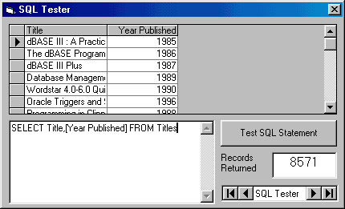

- The DISTINCT keyword can be used with SELECT to restrict the returned records to one per unique entry for the field. That is, there are no duplicate entries. As an example, first try this with the SQL tester:

SELECT PubID FROM Titles

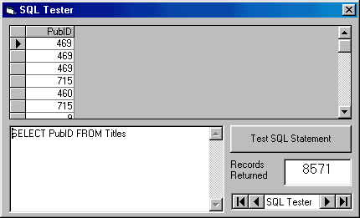

Now, try:

SELECT DISTINCT PubID FROM Titles

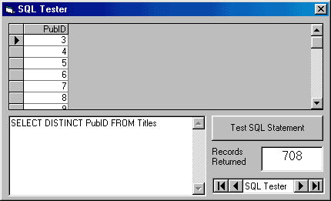

You should see far fewer records are returned - only distinct publishers are returned.

ORDER BY Clause

- When you use a SELECT/FROM statement, the records are returned in the order they are found in the selected table(s). To sort the returned records in some other order, you use the ORDER BY clause. The syntax is:

SELECT [Fields] FROM [Tables] ORDER BY FieldSort

This statement selects the listed fields from the listed tables and sorts them by the field named FieldSort. By default, the ordering is in ascending order. If you want the sort to be in descending order, the FieldSort name is followed by the keyword DESC.

- Try this statement with the SQL Tester:

SELECT * FROM Titles ORDER BY PubID

All records in the Titles table will be returned in order of Publisher ID.

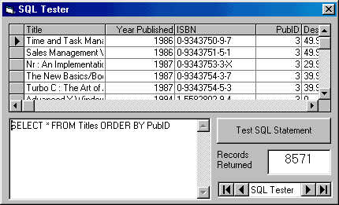

Try this and the order should be reversed:

SELECT * FROM Titles ORDER BY PubID DESC

- You can use more than one field in the ORDER BY clause. SQL will create a recordset based on all requested orderings. Try this with SQL tester:

SELECT * FROM Titles ORDER BY PubID,Title

The returned records will be in order of the publishers, with each publisher’s titles in alphabetic order.

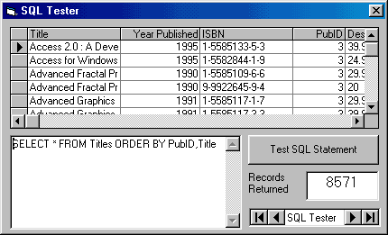

- If you want to restrict the number of records returned by a SQL statement that orders the returned records, you can use the TOP keyword with SELECT. TOP n returns the first n records. TOP n PERCENT returns the first n percent of the returned records. If two or more records have the same order value, they are all returned. Use the SQL Tester and try:

SELECT TOP 20 * FROM Titles ORDER BY PubID,Title

Twenty books should be returned. Now, try:

SELECT TOP 20 PERCENT * FROM Titles ORDER BY PubID,Title

Far more books will be returned.

WHERE Clause

- One of the most useful aspects of the SELECT/FROM SQL statement is its ability to limit the returned recordset via the WHERE clause. This clause specifies some criteria that must be met in forming the recordset. The syntax is:

SELECT [Fields] FROM [Tables] WHERE Criteria

- The WHERE clause limits the number of returned records by allowing you to do logical checks on the value of any field(s). Operators used to perfom these checks include:

< Less than <= Less than or equal to
> Greater than >= Greater than or equal to
= Equal <> Not equal

Other operators are:

Between Within a specified range
In Specify a list of values
Like Wild card matching

The WHERE clause can limit information displayed from one table or combine information from one or more tables. First, let’s do some several single table examples using SQL Tester.

Single Table WHERE Clause

- Say we want to see all fields in the BIBLIO.MDB Titles table for books published after 1995. And, we want the returned records ordered by Title. The SQL statement to do this is (we’ll type each clause on a separate line to clearly indicate what is going on - multiple line SQL statements are acceptable and, many times, desirable):

SELECT *
FROM Titles
WHERE [Year Published] > 1995
ORDER BY Title

This is where the real power of SQL comes in. With this simple statement, the Jet database engine quickly finds the desired records and sorts them - all without any coding on our part!

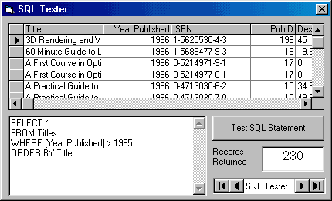

- What if we want to know information about all the book publishers in the state of Washington. Try this SQL statement with the BIBLIO.MDB Publishers table:

SELECT * FROM Publishers WHERE State = ‘WA’

Note we enclosed the state name abbreviation (a string) in single quotes, as discussed earlier in this chapter. Try this SQL statement with the SQL tester and you should find one lonely publisher (BetaV) in the state of Washington! Wonder where Microsoft is?

- The BETWEEN keyword allows us to search for a range of values. Want all books published between 1995 and 1998? Use this SQL statement:

SELECT * FROM Titles WHERE [Year Published]
BETWEEN 1995 AND 1998

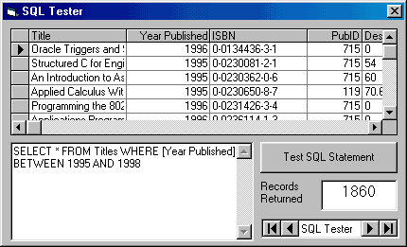

- The IN keyword lets us specify a comma-delimited list of desired values in the returned recordset. Say, we want to know the publishers in New York, Massachusetts, and California. This SQL statement will do the trick:

SELECT * FROM Publishers WHERE State IN (‘NY’, ‘MA’, ‘CA’)

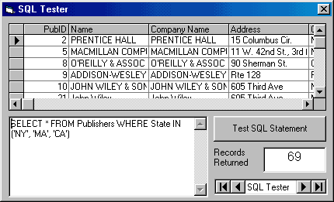

- The LIKE keyword allows us to use wildcards in the WHERE clause. This lets us find similar fields. Recall, the Jet engine wildcard character is the asterisk (*). To find all authors with a ‘g’ anywhere in the their name, try:

SELECT * FROM Authors WHERE Author LIKE ‘*g*’

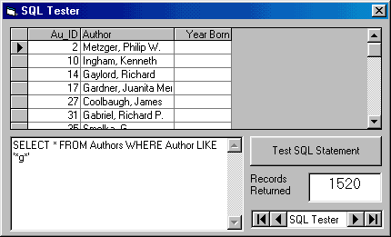

- Multiple criteria are possible by using the logical operators AND and OR. For example, to find all books in the Titles table published after 1993 with a title that starts with the letters Data, we would use the SQL statement:

SELECT * FROM Titles
WHERE [Year Published] > 1993 AND Title LIKE 'Data*'

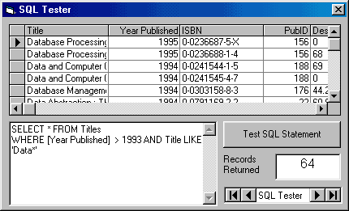
Multiple Table WHERE Clause

- So far, almost everything we’ve done in this course has involved looking at a single native (built-in) table in a database. This has been valuable experience in helping us understand database design, learning how to use the Visual Basic database tools, and learning some simple SQL statements. Now, we begin looking at one of the biggest uses of database management systems - combining information from multiple tables within a database. SQL makes such combinations a simple task.

- We still use the same SELECT/FROM syntax, along with the WHERE and ORDER BY clauses to form our new virtual tables:

SELECT [Fields]
FROM [Tables]
WHERE Criteria
ORDER BY [Fields]

The only difference here is there’s more information in each SQL statement, resulting is some very long statements. The [Fields] list will have many fields, the [Tables] list will have multiple tables, and the Criteria will have several parts. The basic idea is to have the SQL statement specify what fields you want displayed (SELECT), what tables those fields are found in (FROM), how you want the tables to be combined (WHERE), and how you want them sorted (ORDER BY). Let’s try an example.

- Notice the Titles table does not list a book’s publisher, but just publisher identification (PubID). What if we want to display a book’s title (Title field in Titles table) and publisher (Company Name in Publishers table) in the same recordset? Let’s build the SQL statement. First, the SELECT clause specifies the fields we want in our ‘virtual’ table:

SELECT Titles.Title,Publishers.[Company Name]

Note the use of dot notation to specify the desired fields. With multiple tables, this avoids any problems with naming ambiguities.

- The FROM clause names the tables holding these fields:

FROM Titles,Publishers

- The WHERE clause declares what criteria must be met in combining the two tables. The usual selection is to match a primary key in one table with the corresponding foreign key in another table. Here, we want the publisher identification numbers from each table to match:

WHERE Titles.PubID = Publishers.PubID

Any records from the tables that do not match the WHERE criteria are not included in the returned recordset.

- Lastly, we declare how we want the resulting recordset to be sorted:

ORDER BY Titles.Title

- The complete SQL statement is thus:

SELECT Titles.Title,Publishers.[Company Name]

FROM Titles,Publishers
WHERE Titles.PubID = Publishers.PubID
ORDER BY Titles.Title

Try this with the SQL tester.

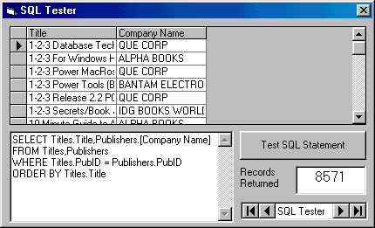

- Are you amazed? You have just seen one of the real powers of using SQL with the Jet database engine (or any database system, for that matter). We simply told the engine what we wanted (via the SQL statement) and it did all of the work for us - no coding needed! Let’s do some more examples.

- In the previous example, say you just want books published by Que Corporation. Modify the SQL statement to read (we added an AND clause):

SELECT Titles.Title,Publishers.[Company Name]
FROM Titles,Publishers
WHERE Titles.PubID = Publishers.PubID
AND Publishers.[Company Name] = ‘QUE CORP’
ORDER BY Titles.Title

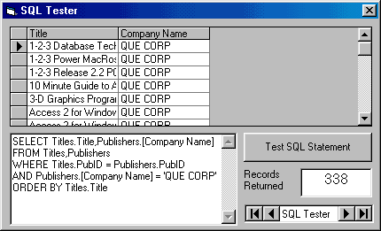

- What if we want to list a book’s title, publisher, and author, ordered by the author names? This requires using all four tables in the BIBLIO.MDB database. Let’s build the SQL statement. We want three fields:

SELECT Authors.Author,Titles.Title,Publishers.[Company Name]

As mentioned, to retrieve this information requires all four tables:

FROM Authors,Titles,Publishers,[Title Author]

We still need the publisher identification numbers to match, but now also need to make sure book titles (via the ISBN field) and author identification numbers match. The corresponding WHERE clause is:

WHERE Titles.ISBN = [Title Author].ISBN

AND Authors.Au_ID = [Title Author].Au_ID
AND Titles.PubID = Publishers.PubID

Finally, the results are sorted:

ORDER BY Authors.Author

Putting all this in the SQL tester gives us over 16,000 listings (one entry for every author and every book he or she wrote or co-wrote):

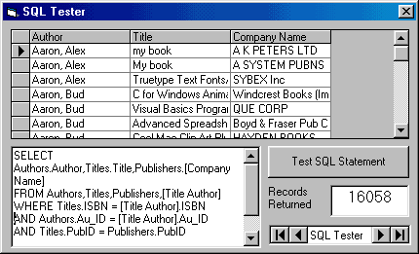

Such power! Can you imagine trying to write BASIC code to perform this record retrieval task?

- If the displayed field name does not clearly describe the displayed information, you can alias the name, or change it to something more meaningful using the AS clause. As a simple example, try this:

SELECT Au_ID AS [This Author] FROM Authors

Notice the displayed column is now This Author.

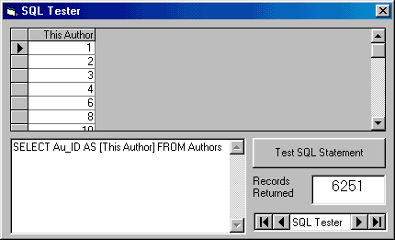

The field name is unaffected by aliasing - only the displayed name changes.

- Important - Database tables combined (forming a virtual data view) using DAO technology and the SQL WHERE clause cannot be updated. The data can only be viewed. Go ahead - combine tables using a SQL statement with a WHERE clause and try to change a value in the resulting grid. You can’t do it! The ability to update a DAO recordset is established by the read-only Updatable property. Is this a problem? Not if you are just displaying information for a user. But, if you need editing capabilities with DAO, do not use the WHERE clause to join tables.

- Any recordset established using ADO technology (even with a combining WHERE clause) can be updated, depending on locks placed on the recordset. The use of such locks is discussed in a later chapter.

- To provide editing in DAO recordset, you need to use the SQL JOIN clauses. Using JOIN clauses will also work with ADO recordsets. Let’s take a look at such a clause.

INNER JOIN Clause

- When combining tables, the SQL INNER JOIN clause does the same work as the WHERE clause and it returns a recordset that can be updated (for both DAO and ADO technologies). The syntax for an INNER JOIN is a little different than that of the WHERE clause.

SELECT [Fields]
FROM Table1 INNER JOIN Table2 ON Linking Criteria
WHERE Criteria
ORDER BY [Fields]

This rather long statement begins by specifying the fields to SELECT. The FROM clause specifies the fields will come from the first table (Table1) being INNER JOINed with a second table (Table2). The ON clause states the linking criteria (usually a matching of key values) to be used in the join. At this point, the tables are combined. You can still use a WHERE clause to extract specific information from this table (you just can’t use it to combine tables) and an ORDER BY clause, if desired. Let’s repeat the examples just done with the WHERE clause.

- To display a book title and publisher name, the SELECT clause is:

SELECT Titles.Title, Publishers.[Company Name]

We want to ‘join’ the Titles table with the Publishers table, making sure the PubID fields match. The corresponding INNER JOIN statement is:

FROM Titles INNER JOIN Publishers
ON Titles.PubID = Publishers.PubID

Lastly, we order by the Title:

ORDER BY Titles.Title

Try this SQL statement in the SQL tester and you should obtain the same results seen earlier with the WHERE clause:

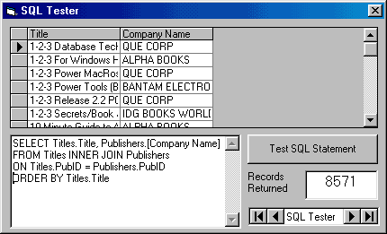

- Try to change a value in the data grid for this example. You should see that, as expected, use of the INNER JOIN provides an updatable recordset. If you leave your change as is, it will be written as a permanent modification to the database! So, we suggest ‘undoing’ your change. You have just learned one of your first skills in building a complete database management system - how to edit an existing database. It was easy, wasn’t it? This ease comes from the power of the Jet database engine. There are times we won’t want editing the database to be so easy. Limiting these capabilities are discussed in the next chapter on Visual Basic interfaces.

- To illustrate use of the WHERE clause (to limit displayed records) in conjunction with the JOIN clause, try this modified SQL statement with SQL Tester:

SELECT Titles.Title, Publishers.[Company Name]

FROM Titles INNER JOIN Publishers
ON Titles.PubID = Publishers.PubID
WHERE Publishers.[Company Name] = ‘QUE CORP’
ORDER BY Titles.Title

Only QUE CORP publishers will be listed. And, the recordset can still be edited (WHERE only affects ‘updatability’ of DAO recordsets when used to combine information on tables).
- Use of the INNER JOIN clause to combine information from more than two tables is a little more complicated. The tables need be joined in stages, nesting the INNER JOIN clauses using parentheses for grouping. Assume we have three tables (Table1, Table2, Table3) we want to combine. Table1 and Table3 have a common key field for linking (Key13), as do Table2 and Table3 (Key23). Let’s combine these three tables using INNER JOIN. In the first stage, we form a temporary table that is a result of joining Table2 and Table3 using Key23 for linking:

Table2 INNER JOIN Table3 ON Table2.Key23 = Table3.Key23

In the next stage, we join Table1 with this temporary table (enclose it in parentheses) using Key13 for linking:

Table1 INNER JOIN
(Table2 INNER JOIN Table3 ON Table2.Key23 = Table3.Key23)
ON Table1.Key13 = Table3.Key13

This nested statement is used in the SQL statement to specify the tables for field selection. Notice we’ve spread this over a few lines to make it clearer - any SQL processor can handle multiple line statements. The multiple table INNER JOIN can be generalized to more tables - just pay attention to what tables link with each other. Always make sure the tables you are joining, whether a temporary joined table or a database table, have a common key.

- Remember the example we did earlier where we listed Author, Title, and Publisher in the BIBLIO.MDB database? Let’s build that SQL statement. First, SELECT the fields:

SELECT Authors.Author,Titles.Title,Publishers.[Company Name]

This is the same SELECT we used previously. Now, we need to form the FROM clause by combining four tables in three stages (one for each common key linking). In the first stage, combine the Publishers and Titles tables (PubID is common key):

Publishers INNER JOIN Titles
ON Publishers.PubID=Titles.PubID)

Now, join this temporary table (put its statement in parentheses) with the [Title Author] table (ISBN is common key):

(Publishers INNER JOIN Titles
ON Publishers.PubID=Titles.PubID)
INNER JOIN [Title Author]
ON Titles.ISBN=[Title Author].ISBN

In the final stage, join the Authors table with this temporary table (enclose its statement in parentheses) using Au_ID as the key:

Authors INNER JOIN
((Publishers INNER JOIN Titles
ON Publishers.PubID=Titles.PubID)
INNER JOIN [Title Author]
ON Titles.ISBN=[Title Author].ISBN)
ON Authors.Au_ID=[Title Author].Au_ID

The FROM clause needed for the combined data view is now complete. The final line in the SQL statement orders the data:

ORDER BY Authors.Author

Whew! Try this full statement with the SQL tester and you should get the same results seen earlier using the WHERE clause. The difference, of course, is that the recordset here can be updated.

OUTER JOIN Clause

- The INNER JOIN only retrieves records that have a match on both sides of the JOIN. For example, with BIBLIO.MDB, the INNER JOIN statement:

Publishers INNER JOIN Titles ON Publishers.PubID = Titles.PubID

In this statement, if there is a PubID in the Publishers table without a corresponding PubID in the Titles table, that value will not be in the returned recordset. If you want all records returned, whether there is a match or not, you need to use what is called an OUTER JOIN. There are two forms for the OUTER JOIN.

- A RIGHT OUTER JOIN includes all records from the second-named table (the right-most table), even if there are no matching values for records in the first-named (left-most table). Try this with SQL Tester:

SELECT Titles.Title, Publishers.[Company Name]
FROM Titles

RIGHT OUTER JOIN Publishers
ON Titles.PubID = Publishers.PubID
ORDER BY Titles.Title

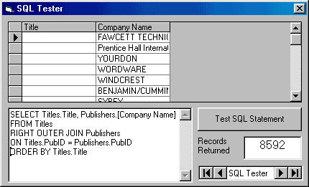

There are several publishers (about 19 or so) without corresponding titles in the database.

- A LEFT OUTER JOIN includes all records from the first-named table (the left-most table), even if there are not matching values for records in the second-named (right-most table). Try this with SQL Tester:

SELECT Titles.Title, Publishers.[Company Name]
FROM Titles
LEFT OUTER JOIN Publishers
ON Titles.PubID = Publishers.PubID
ORDER BY Titles.Title

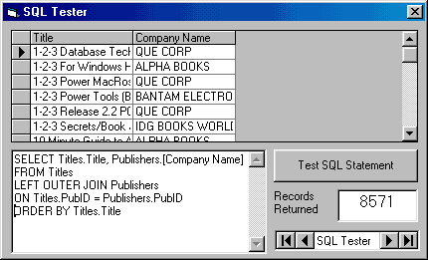

The returned recordset is identical to that obtained with the INNER JOIN. Obviously, all books in the database have a corresponding publisher - that’s actually a good thing.

Visual Basic Functions with SQL

- The Jet database engine allows you to use any valid BASIC function as part of a SQL statement. This lets you modify the displayed information. It does not affect the underlying information in the database. As an example, say you want all book titles in the BIBLIO.MDB Titles database to be listed in upper case letters. Try this SQL statement with SQL Tester:

SELECT UCase(Titles.Title) FROM Titles

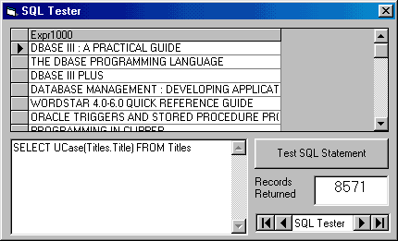

Notice SQL assigns a heading of Expr1000 to this ‘derived’ field. We can use the alias feature of SQL change this heading to anything we want (except the name of an existing field). Try this:

SELECT UCase(Titles.Title) AS Title FROM Titles

- Or, what if we had some process that could only use the 10 left-most characters of the book title. This SQL statement will do the trick:

SELECT UCase(Titles.Title) AS Title FROM Titles

- You can also do BASIC math in a SQL statement. The BIBLIO.MDB database Authors table has Year Born as a field. This SQL statement will display each author and their age in 1999 (when this is being written):

SELECT Authors.Author,(1999-Authors.[Year Born]) AS Age
FROM Authors

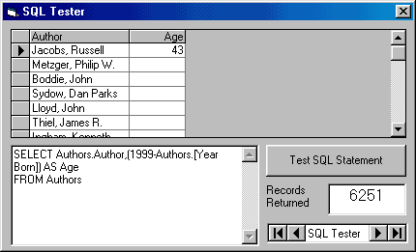

Note that most of the listings do not have an Age value. The reason for this is because only a few of the author records have birth year entries - the entries are NULL (containing no information).

- NULL is a special value meaning there is nothing there - this is not the same as an empty string or blank space. In our work, we will avoid placing NULLs in a database, but they may exist in other databases. You need to decide how to handle NULLs in your design. We will see examples where they cause problems. A NULL field can be tested using the SQL functions IS NULL and IS NOT NULL. We can add this to the SQL statement above to find just the Authors records with a birth year:

SELECT Authors.Author,(1999-Authors.[Year Born]) AS Age
FROM Authors
WHERE Authors.[Year Born] IS NOT NULL

You should now find 20 authors with ages listed.

SQL Aggregate Functions

- In addition to BASIC functions, the Jet database engines supports the standard SQL aggregate functions. These are functions that let you compute summary statistics for fields in your database, alias the results, and display them in a recordset. NULL fields are ignored by the aggregate functions.

- The aggregate functions and their results are:

AVG(Field) Average value of the field
COUNT(Field) Number of entries for the field
FIRST(Field) First value of the field
LAST(Field) Last value of the field
MAX(Field) Maximum value of the field
MIN(Field) Minimum value of the field
SUM(Field) Sum of the field values

- Try this example with the Authors table:

SELECT
COUNT(Authors.Author) AS HowMany,
AVG(Authors.[Year Born]) AS AveYear,
FIRST(Authors.[Year Born]) AS FirstYear,
LAST(Authors.[Year Born]) AS LastYear,
MAX(Authors.[Year Born]) AS MaxYear,
MIN(Authors.[Year Born]) AS MinYear,
SUM(Authors.[Year Born]) AS SumYear
FROM Authors

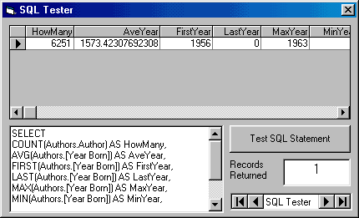
Note some of the aggregate fields (FIrstYear, LastYear) have no values since these are NULL fields.

- Aggregate functions can be used to group results. The GROUP BY clause lets you determine records with duplicate field values. Want to know how many publishers in your database are in each state? Try this SQL statement:

SELECT Publishers.State, Count(Publishers.State) as HowMany
FROM Publishers
GROUP BY Publishers.State

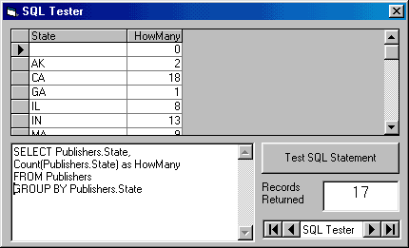

- You can use the HAVING qualifier to further reduce the grouping obtained with a GROUP BY clause. Say in the above example, you only want to display states starting with the letter M (a strange request, we know). This SQL state will do the trick (try it):

SELECT Publishers.State, Count(Publishers.State) as HowMany
FROM Publishers
GROUP BY Publishers.State
HAVING Publishers.State LIKE ‘M*’

